**Sales Data Analysis**

**Purpose :** Analyze sales data to identify trends, top-selling products, and revenue metrics for business decision-making.

**Description:** This project will dive into a large sales dataset to extract valuable insights. You will explore :  
1. Sales trends over time  
2. Identify the best-selling products  
3. Calculate revenue metrics such as total sales and profit margins

Create visualizations to present your findings effectively. This project showcases your ability to manipulate and derive insights from large datasets, enabling you to make data-driven recommendations for optimizing sales strategies.

**Data walk through:**   
OrderID :It consists of all the Order id’s for the order placed (Number format)  
Product: It consists name of the product (Text format)  
Quantity : Quantity purchased (Number format)  
Price each : Price of each good (Decimal number format)  
Order Date : Date when order was placed (Number format)  
Purchase address: Address where purchase is done (Text format)  
Month : Month of order (Number format)  
Sales : Contains the total amount incurred by selling that product (Decimal number format)  
City : City of purchase (Decimal number format)  
Hour: Time(HH) of order placement (Number format)

**Software Used:** PowerBi

**Data Set :** [Data_set_link](https://drive.google.com/file/d/1ziAZRwziK6HMWlKv2Nosqb5wl_kjDwwi/view?usp=drive_link)

**Project link :** <https://github.com/ankit5163/Sales_analysis_mreiskill-P1-.git>

**Changes made in dataset:**  
1. Make a reference sheet to make changes in data set according to our needs

2. Make display Month name by the reference of month number   
  
Month_Name=SWITCH([Month],1,"January",2,"Feburary",3,"March",4,"April",5,"May",6,"June",7,"July",8,"August",9,"September",10,"October",11, "November",12,"December")

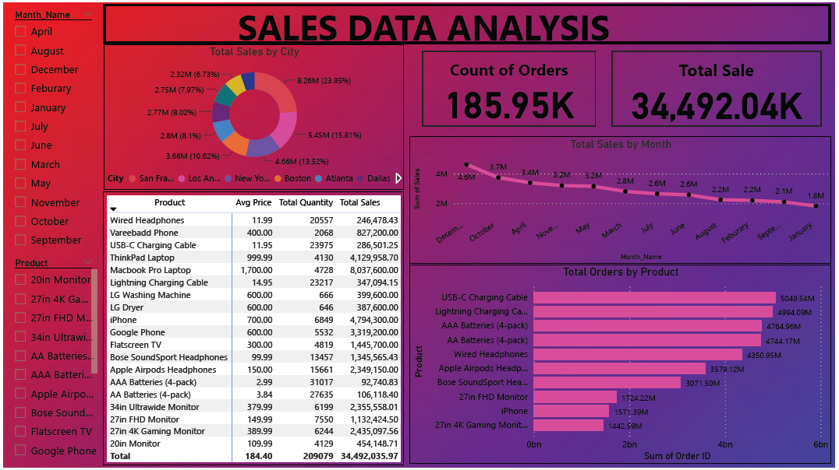

**Analyzing Outcome:**

1. The total number of orders are 185.85 thousand

2. Total sales made is $34492.04 thousand

3. Maximum selling product is USB-C charging cable total sales $5094.54 million followed by lightning charger cable   
 with $4994.09 million . Least selling product is 27 inch 4K gaming monitor with sales of $1442.59 million in the top   
 10 list.

4. The product that is the most expensive is MacBook Pro laptop with the price of $1700. Whereas cheapest product is   
 AAA batteries with price of $2.99.

5. The maximum contribution done in total sales is by MacBook Pro laptop with a contribution of $8 million and the   
 least contribution is done by AAA batteries with contribution of $0.92 million

6. Where has maximum top ten selling products are USB C charging cable->Lightning charging cable ->AAA   
 batteries->AA battery->Wired headphone->Apple airpods->Bose sound->27inch FHD monitor->iPhone->24 inch   
 4K monitor

7. The month with maximum sale was December with $4.6 million followed by October with $3.7 million. The month   
 with minimum sale was January with $1.8 million.

8. Analyzing the pie chart the predicted thing is that San Francisco has largest sales with $8.26 million followed by Los   
 Angeles with $5.45 million. List sales was made in Austin good total sales of $1.8 million

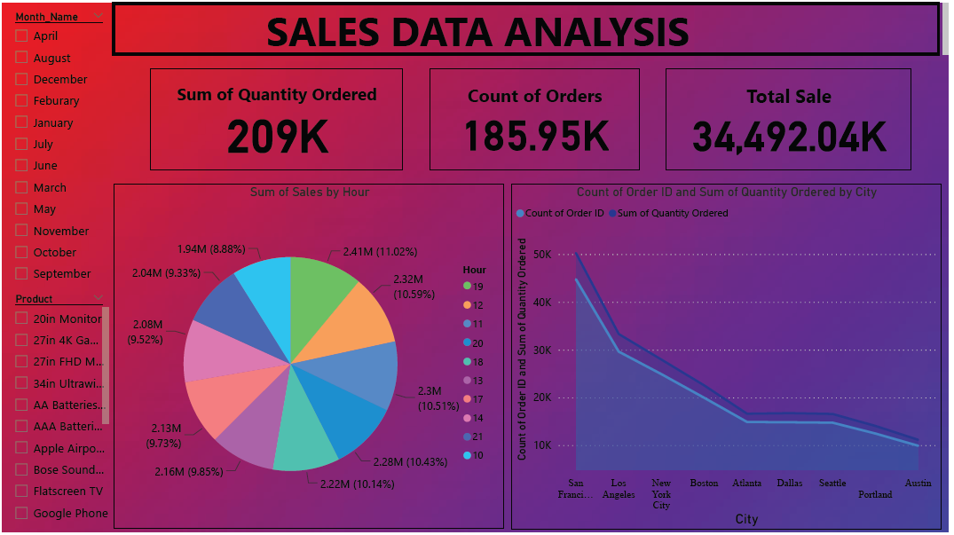

**Analyzing Outcome:**

1. The total quantity order is 209 thousand .
2. So the most famous time where people tend to order the most is 19 hours that is 7:00 PM. Moreover the time where people tend to order least is 10 hours that is 10 AM in the morning.  
   It gives us analysis that the company should release offers and can observe maximum traffic at 7:00 PM , 12:00 PM , 11:00 PM and 8:00 PM.
3. Analyzing the area chart the predicted thing the maximum area of count of orders is covered in San Francisco region followed by Los Angeles and New York. Heads into that sum of ordered quantity is also very hi San Francisco as compared to New York and Los Angeles.  
   Predicting the fact that San Francisco will be the leading market for greatest sales enhancement.